**While Loop, Comprehension & Function**

**Python Assignment**

**3rd Feb. 2023**

**Q1. Which keyword is used to create a function? Create a function to return a list of odd numbers in the range of 1 to 25.**

**Sol.** *def function_name():* is used to create a Function.

Odd_num = [num for num in range(1,25) if num % 2!=0]

print(Odd_num)

**Q2. Why *args and **kwargs is used in some functions? Create a function each for *args and **kwargs to demonstrate their use.**

**Sol.** *\*args* in function definitions in Python is used to pass a variable number of arguments to a function. It is used to pass a non-keyworded, variable-length argument list.

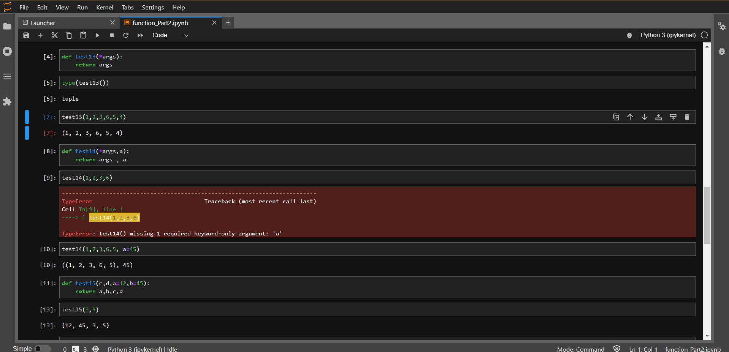 *\*\*kwarsgs* in function definitions in Python is used to pass a keyworded variable-length argument list. We use the name *kwargs* with the double star. The reason is that the double star allows us to pass through keyword arguments (and any number of them).

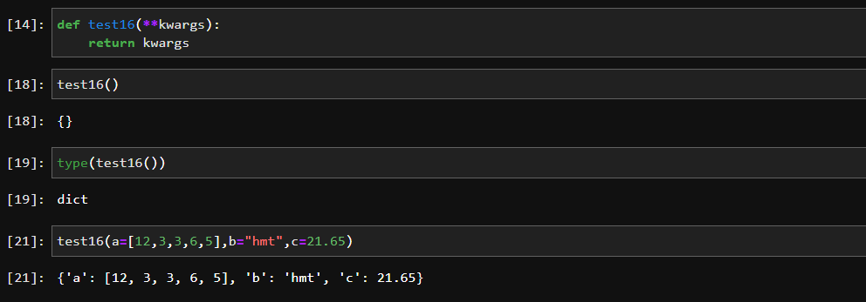

**Q6. Write a python program to print the first 10 Fibonacci numbers using a while loop.**

**Sol.**

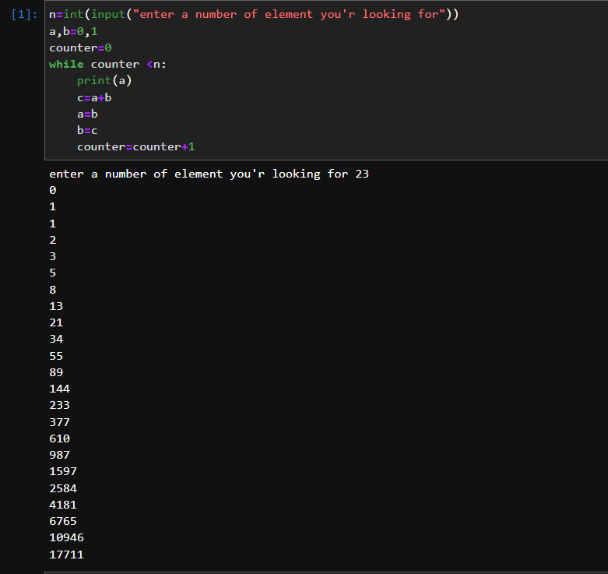

**Q7. Write a List Comprehension to iterate through the given string: ‘pwskills’. Expected output: ['p', 'w', 's', 'k', 'i', 'l', 'l', 's']**

**Sol.**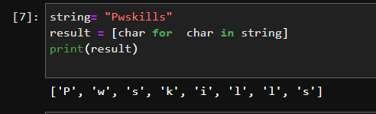

**Q8. Write a python program to check whether a given number is Palindrome or not using a while loop.**

**Sol.**

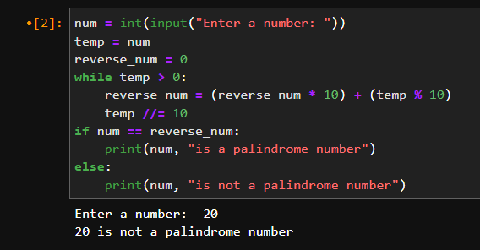

**Q9. Write a code to print odd numbers from 1 to 100 using list comprehension.**

**Sol.**



**Q4.  What is a generator function in python? Why yield keyword is used? Give an example of a generator function.**

**Q5. Create a generator function for prime numbers less than 1000. Use the next() method to print the first 20 prime numbers**

**“Q4 and Q5 is from upcoming topic. so I will do both questions in next assignment”**